A000-AM,S-Peru-Moche-Pendant-Anthropomorphic-100-700 CE

* Length: 1.77 in - 4.5 cm

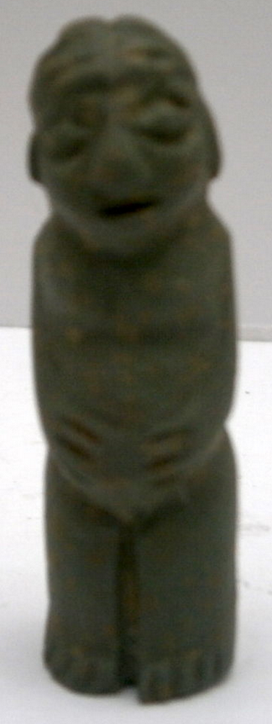

Case No. 10